Name Period Date

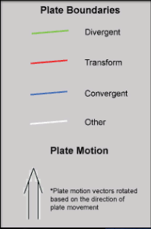
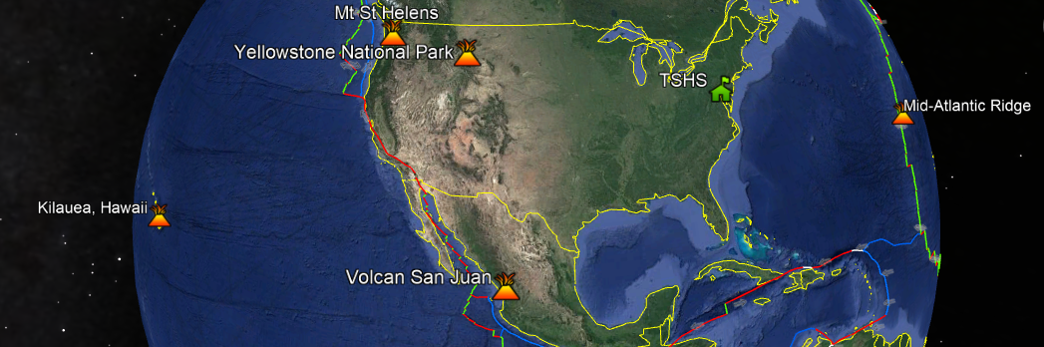
Part C: Where Do Volcanoes Form? (Discovery Education - Concept 8.1 “Formation of Volcanos”; Explore Page 2)
 | Kilauea, Hawaii | Mt. St. Helens, WA &  Volcan San Juan, Mexico | Yellowstone  National Park, WY | Mid Atlantic Ridge
Type of Boundary or Hot Spot
Type of Volcano
Amount of Silica (Low/Med/High)
Viscosity (Low/Med/High)
Explosive Tendancy
Material Formed
* Note: Oceanic-Oceanic subduction zone magma/lava gets ______ silica and is therefore _______ explosive and _______ viscous.

